**An Evolving Society: Vacations and the Emerging Middle Class**

From about the 1860’s some affluent Montrealers chose the shores of Lake Memphremagog to escape the heat, noise and pollution of that increasingly industrialized city. North of Magoon Point such notables as the Allans, Murrays, and the Molsons, established expansive summer residences, as has been well-documented by Robinson (2016), and Abbott (2017). The Ogden shoreline was largely steep, rocky and forested, only broken here and there by farmers’ pastures where gentler slopes prevailed. Only in Harvey’s Bay did a wharf beckon the steamboats to call, and certainly no cottages, let alone imposing mansions, disturbed the lakeshore. For about a quarter century, very little changed.

In the early to mid 19th century, outside of the elite, the ownership of shoreline property for purely recreational purposes simply did not exist. However it was also after the American Civil War that a self-identified middle class began to emerge, both in Canada and the U.S. Massive industrialization brought with it a significant growth of managerial and senior clerical support staff. At the same time, a greater respect and accreditation was awarded certain professional streams (doctors, lawyers, etc.), which meant that an increasing proportion of the population could accumulate some modest savings, and at least contemplate taking a small amount of time off of work. The concept of vacations began to take root, and more and more the ability to take a vacation became a prime means of differentiating the middle class from the labour class. Some enlightened employers even began to provide paid vacations, as medical opinion began to promote the health and productivity benefits of annual leave.

As pointed out by Aron (1999), there existed a fundamental tension to taking such holidays, as pleasurable leisure was viewed with puritanical suspicion. As a consequence many vacations taken in the 2nd half of the 19th century were tempered with an element of self-improvement, and as a consequence mineral springs (health), religious revivals/gathering (morality, salvation), and touring and chattaquas (broadening one’s knowledge), were all considered more acceptable forms of vacation.

Camping in the wilderness, or at least in rural settings, was also considered an acceptable and productive way to spend time off, combining as it did healthful exertion, fresh air, and spiritual reflection. Cottage building and cottage life grew directly, if gradually, out of the camping movement (e.g. Barrow,1887; see also Pfeffer,2014).

The use of the Ogden shoreline for temporary summer stays, can be traced back to about 1885 with the completion of the Cedarville Inn[1]. Constructed by James H. Merrill, who at that time owned the saw mill in Smith Mills (Tomifobia), the Inn was intended to attract summer visitors travelling on the Lady of the Lake and other steamers. The Cedarville subport was still open, and obliged the steamboat captains to report in at the Custom’s increasingly dilapidated wharf. The Inn promised to be a profitable venture but alas, the subport was closed within two years and the Inn became a white elephant.

Cedarville’s entrepreneurial farmer, Joseph Commer Bullis (see ensuing section), resolutely faced this challenge and reconfigured the abandoned Customs office that was situated on his land as a cottage to rent in 1887, and in 1890 rebuilt the steamboat wharf. Meanwhile new owner Lucy Ann Reed gamely tried to make a go of the Inn. In the long run neither venture proved viable, besides which a new trend was taking shape along the shoreline. Instead of short stays at a lakeside hotel, it was becoming fashionable to purchase one’s own summer property. In 1886 Andrew Zabreskie, a wealthy American from New York City, purchased Province Island as a summer retreat, and in 1892 the Covell family, also from New York City, bought the Cedarville Inn as a summer residence. Just across the border on the American side, cottages were being erected at Lake Park north to Eagle Point, starting in about 1885.

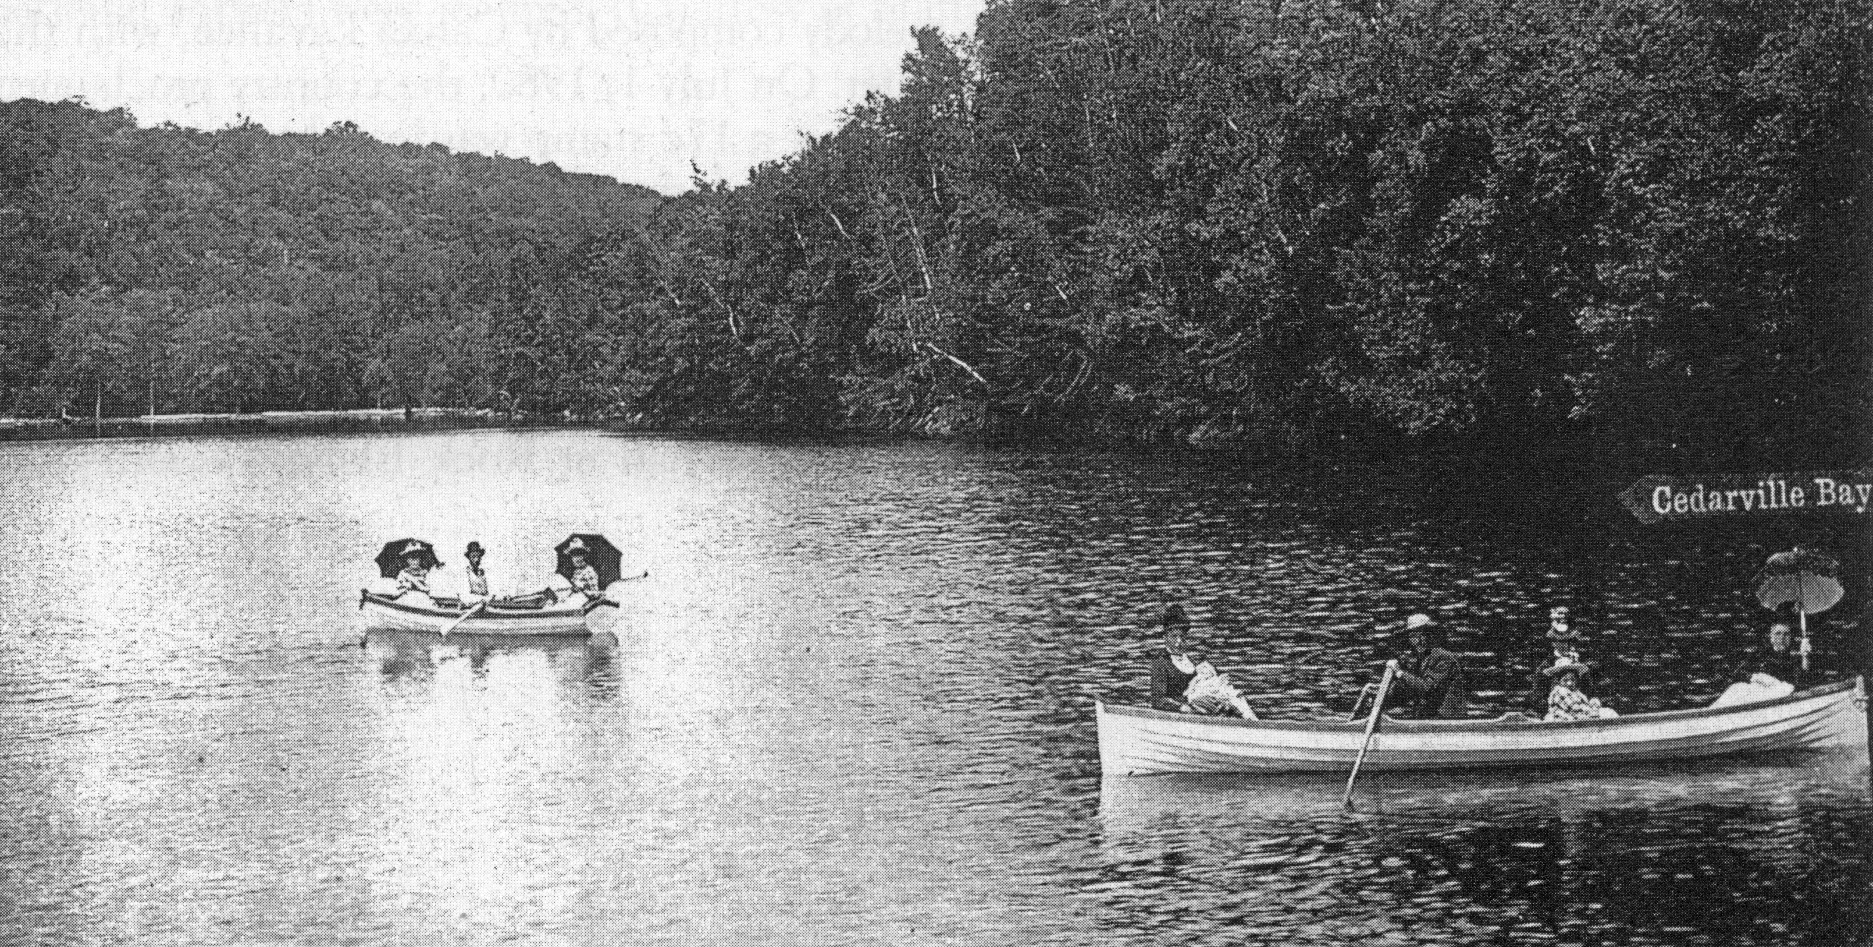

***Promotional image put together for Joseph Bullis showing the delights of vacationing near Ceadarville, circa 1890.***

As discussed in the related article on the *Plebian Eastern Shore*, lakefront properties in Ogden started to be sold in 1904 and continued up until WW1, purchased largely by local residents in the Stanstead region. Further development occurred through the 20’s and 30’s attracting a greater proportion of Montrealers, but the major boom in cottages commenced in the late 1940’s and continued through the 1960’s, spurred on by a substantial rise in median incomes, five day work weeks, and with the automobile now allowing families to travel greater distances and on their own schedules. Montreal to Ogden could now be accomplished in as little as 3 hours on the old route __.

Since 1913 the footprint of the villégiateur (summer resident) has increased an astonishing 820% in Ogden. Locally cottage densities run at 22 cottages per kilometre of shoreline.

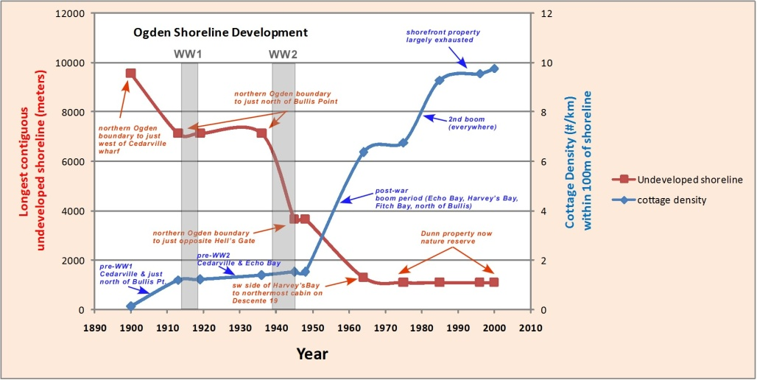

Shoreline development in Ogden has been unrelenting over the past decades but perhaps is approaching its maximum, as there remains little land to sub-divide, and the Municipality in 199_ enacted minimum building Lot sizes.

We are very fortunate that large tracts of shoreline (e.g. Dunn Nature Reserve) are now protected. However the trend of McMansions replacing congenial cottages will continue to the advantage of a few and the collective detriment of many.

1. We refer to it as such, however its actual name is currently lost to history.